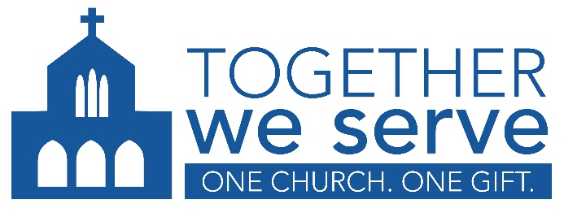

PRAYERS OF THE FAITHFUL 2026

General

For all members of the Family of God, that we may gratefully accept the gifts we have been given and freely share them in compassion and mercy through the Together We Serve Annual Appeal. We pray to the Lord. R.

For our parish family, that a spirit of unity and charity may bind us together and make us effective in all the good works carried out by the charities included in Together We Serve. We pray to the Lord. R

For the charities supported by Together We Serve, that our gifts may enable their work to serve the needs of those here in our midst and those around the world. We pray to the Lord. R.

For each of us, that we open our hearts to how God is calling us to the ministry of charity and the service of mercy through Together We Serve. We pray to the Lord. R.

For our parish, that collectively through Together We Serve we can live the Word of God. We pray to the Lord. R.

For us, together as one family in Christ, that we may bring the goodness and tenderness of God to all we support through Together We Serve. We pray to the Lord. R.

Catholic Social Services Sunday – November 1 (TBC)

For Catholic Social Services, that it may continue to bring hope to the most vulnerable members of our community through our support of Together We Serve and the Sign of Hope campaign. We pray to the Lord. R.

Society of St. Vincent de Paul – World Day of the Poor, November 15

For the Society of St. Vincent de Paul on this World Day of the Poor, that it may continue to serve the poor and marginalized in our community, through our support of Together We Serve. We pray to the Lord. R.

