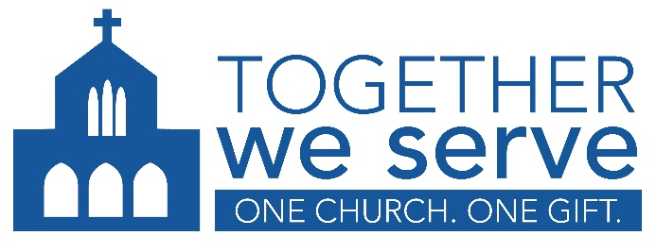

PARISH SPEAKING NOTES 2026

2026 Goal: $1,540,000

General

The Archdiocese of Edmonton launched Together We Serve in 2014 to simplify giving by combining all special collections in parishes into a single annual appeal.

The Mission of Together We Serve is to invite Catholics and others in the Archdiocese of Edmonton to give joyfully and generously to Catholic organizations that serve those in need at home, in Canada, and abroad, as we work together to advance the Mission of the Catholic Church.

For more information about Together We Serve, visit caedm.ca/TogetherWeServe

Connection to Pastoral Priorities

Together We Serve is not just another charity. It is the way we, as Catholics, come together to carry out the mission of the Church in the Archdiocese of Edmonton – through the pastoral priorities of Worship, Witness and Service.

Worship. Together We Serve supports the formation of new priests, a dignified retirement for older priests, and celebration of the Eucharist in Canada’s northern communities.
26% of your gift goes to:
- St. Joseph Seminary
- St. Joseph Priest’s Foundation
- Diocese of Mackenzie-Fort Smith.

Witness. Together We Serve supports the formation of confident witnesses through theological education and faith formation at our Catholic colleges, and evangelization in Canada and beyond.
25% of your gift goes to:
- St. Joseph’s College at the University of Alberta
- Newman Theological College
- Evangelization of Nations

Service. Together We Serve protects life and strengthens families through services provided by Catholic charities in our community, country and beyond.
44% of your gift goes to:
- Catholic Social Services-Sign of Hope
- Society of St. Vincent de Paul-Edmonton Central Council
- Needs of the Canadian Church
- Papal Charities
- Needs of the Church in the Holy Land

An additional 5% of funds are reserved for emerging LOCAL priorities selected by the Archbishop.

Parish Information

Check the monthly financial report for your parish target and current total.

Our parish target is: $XX,000

To the end of <MONTH>, you have given $XX,000 to Together We Serve, or XX% of our target.

How was our parish target determined?
- When Together We Serve began in 2014, the Archdiocese looked at how much our parish gave to special collections each year and then calculated a 5-year average.
- The Archdiocese reviews parish targets in consultation with each pastor and revises the target, if necessary, to provide one that is both achievable and inspiring for parishioners.
The criteria for reviewing and revising parish targets includes:
  - trends in giving
  - number of registered families
  - average donation per family
  - demographic changes in the parish and/or community
  - other factors identified by the parish (e.g. emergent financial needs)

How much should I give?
- Only you can answer that question. As disciples of Christ, we should listen to how God might be calling each of us to serve others through our charitable giving – and to respond generously in gratitude for the abundance we have received.
- I invite you to take the time to pray about it and discern how Together We Serve fits into your life of discipleship.
- The average annual gift is about $500 – or less than $50 per month. Many people choose to give weekly or monthly.

